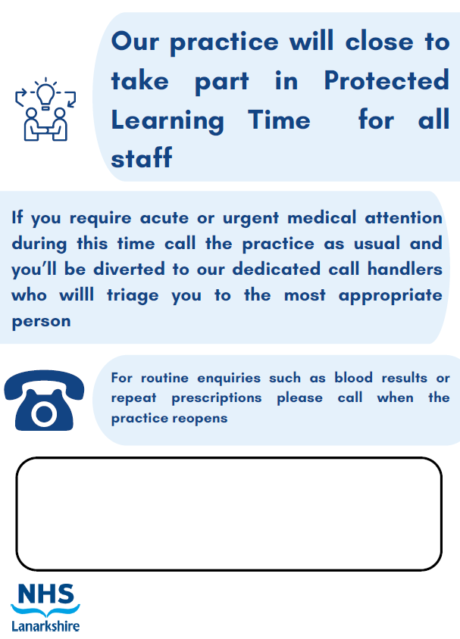

**Wednesday 19th March 2025**

**2pm – 6pm**

**The practice will reopen on Thursday 20th March 2025 at 8am**